在某个文件夹目录下 type “explorer .”打开当前文件夹

在任何根目录下type” explorer” 为打开我的电脑

Type ls

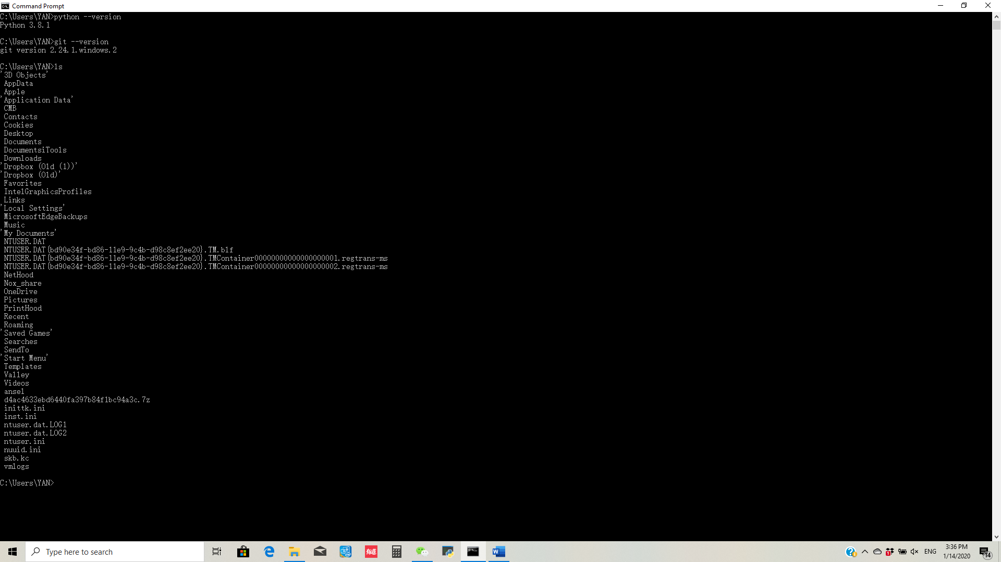

Type: mkdir <folder name> to set up a new folder, 若文件夹为多个英文字母，需用””括起来如: mkdir “machine learning”

Then, type ls to check

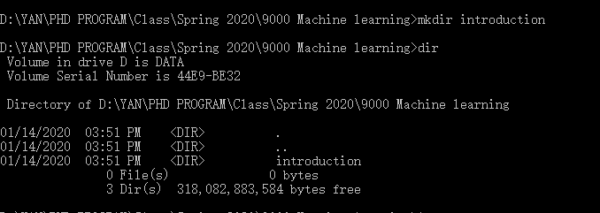

Type “pwd” to check your location



Type “touch a.md” to create a file named “a.md”

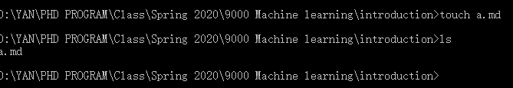

“a” is the name, “md” is the extension

Type “touch a.docx” to create a word file

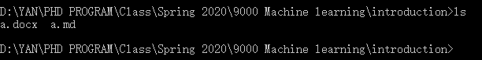

Draw the whole folder into Sublime to open the whole project:

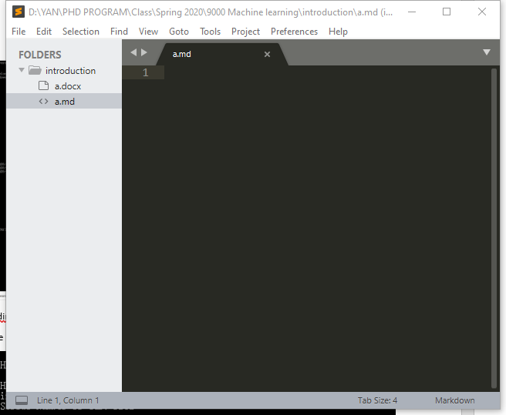

If you want to know what is in the file, type “cat <file name>” 如果忘记加文件名，按ctrl +Z退出

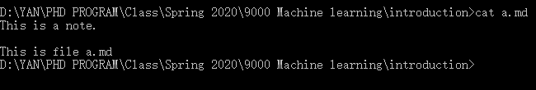

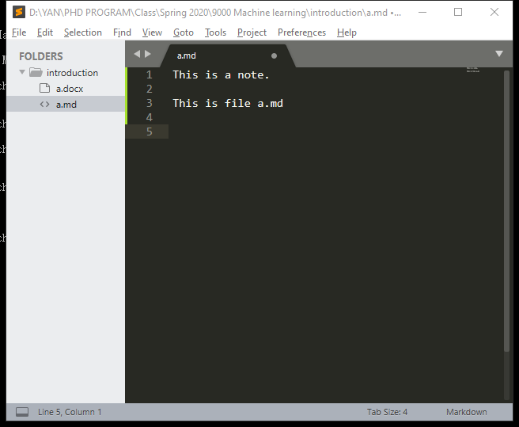

Type: ls -la to check the last time file is opened

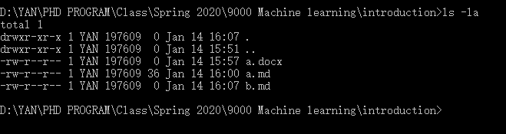

Type: touch a.md again to open it at this time. You can change the information when you then type ls -la

Type “touch hello.py” to create a python file

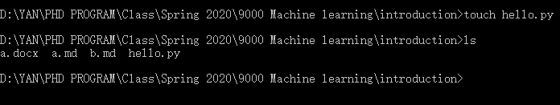

Type “Python hello.py” to run file

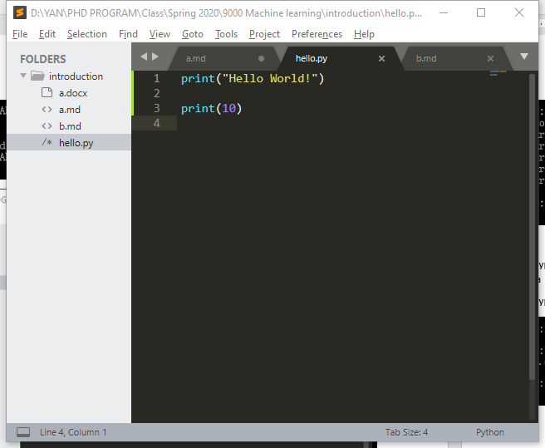

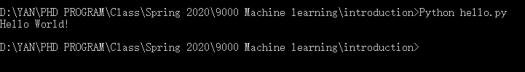

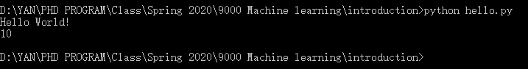

You need to add “” if you want to print a word. But you will not need “” when you print a number.

If you did not put “”

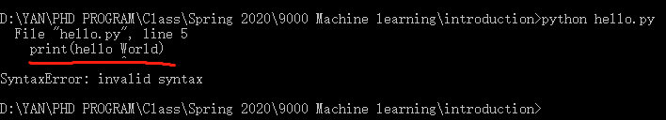

In sublime:

Type

“from datetime import datetime

Print(datetime.now())

“

Run in cmd to show the time now

“import” command for import a package

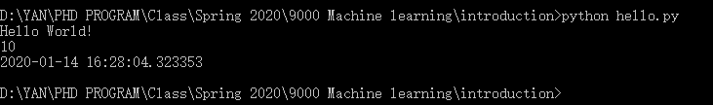

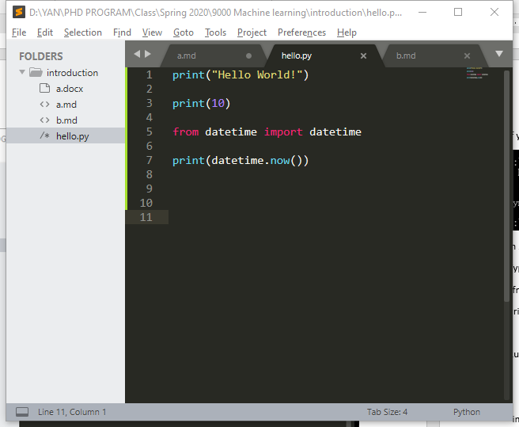

How to install a package (pandas, numpy, sklearn, bs4)

Type

“python -m pip install pandas

Python -m pip install numpy

Python -m pip install sklearn

Python -m pip install bs4

“

